Hey high school music students! You have the wonderful opportunity to be part of a music program that brings joy to your soul, provides a blessing to the audience, and brings pride to your school! Come and be a part of the choir and/or the band where you will develop your musical abilities by learning a variety of musical repertoire and taking part in large and small ensemble performances. You will perform at a variety of venues and events and go on music tours. As you may already know, science has proven that playing a musical instrument strengthens every part of your brain, and therefore helps you to perform well in all your other subjects, too. And besides, it’s just a whole lot of fun! Come and be a part of a wonderful musical adventure. You know you want to! Check out the syllabus to see what you can expect when you sign up.

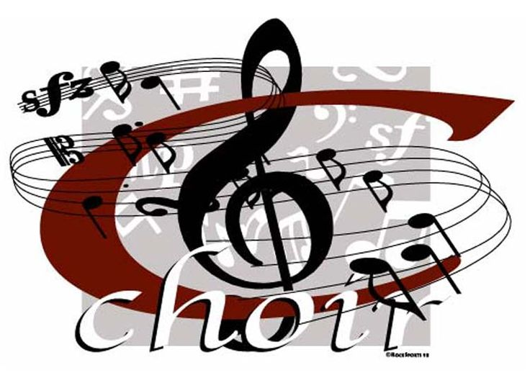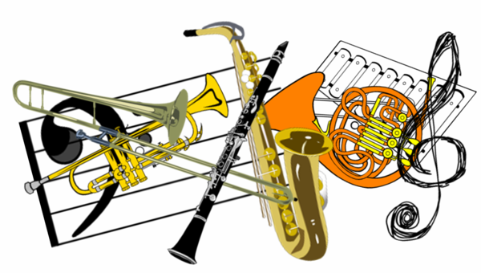

Music Syllabus 2021-2022
For Grades 10-12

Assessment

- Class Participation 35%
- Performances 30%
- Playing Tests 20%
- Assignments/Projects 15%

Personal practicing is expected to be completed regularly each week, however, there will be no practice sheets to complete/submit. Instead, students are required to complete regular playing or singing quizzes every 2 to 3 weeks. Each instrument group is required to attend one weekly sectional practice during lunchtime. (Schedule TBA) Attendance at the sectional is counted toward your participation grade.

Class Participation

Students are expected to come to class promptly and prepared with their instrument, music, folder and pencil. Appropriate class participation includes respecting the teacher and classmates, and participating by playing or singing with effort, energy, and enthusiasm. Sometimes, good class participation means being quiet and just listening! At other times, it means helping a peer to perform their part better. Basically, use common sense and be cooperative with a positive attitude. We all want to make great music together!

Performances

Participation in performances is mandatory. Music is a performing art and therefore all students are required to take part. Performances will include, but not limited to: chapel singing or playing, church presentations, in-school special events and assemblies, community events, Christmas concert and spring concert. Students are expected to plan well in advance to make sure they are at the performance location on time for the warmup and prepared with appropriate performance attire and instrument. Performance events will be posted on the school website calendar at least one month prior to the date.

Performance Attire

For performances requiring formal wear, students will wear the following:

Girls – All black dress with sleeves, modest neckline, black pantyhose and black
dress shoes. Or, a black top with black pants – NO RIPPED JEANS. A blue
scarf will be provided and must be returned after the performance.

Boys – A black long-sleeved shirt with a collar, black pants and belt, and black dress
shoes. NO RIPPED JEANS. A blue tie will be provided and must be returned
after the performance.

For performances requiring casual wear, students will wear the following:

FVAA Music T-shirt, jeans (no rips!) and dark shoes. The FVAA Music T-shirt can be purchased from the music department for $15.00.

Tests, Quizzes, and Assignments

Playing tests and quizzes will be completed in person with the teacher OR submitted digitally via a recording. More details regarding this process will be provided in class.

Assignment submissions will vary, depending on the assignment and/or project. They can be either in person, or via an online music platform, or in the TEAMS music group chat. Assignments/projects may include theory, research, listening activity, composition, a concert review, or small ensemble, duet or solo performances.

Fundraisers

Students will cooperate in fundraising projects and events for tours and other performance expenses. Also, the collection of all FVAA beverage recycling containers will be completed bi-weekly by small groups in either the band or choir class. The money raised from these deposits will be allotted to the music tour fund.

Communication

Students will be part of a High School Band and/or Choir TEAMS group where they can view any information they will need for their course, including performance dates, a list of tests, quizzes, and assignments, and any updates or other important announcements. They can use this platform to communicate with one another as well as with the teacher. Students are encouraged to use this tool to share their musical adventure with the class!

